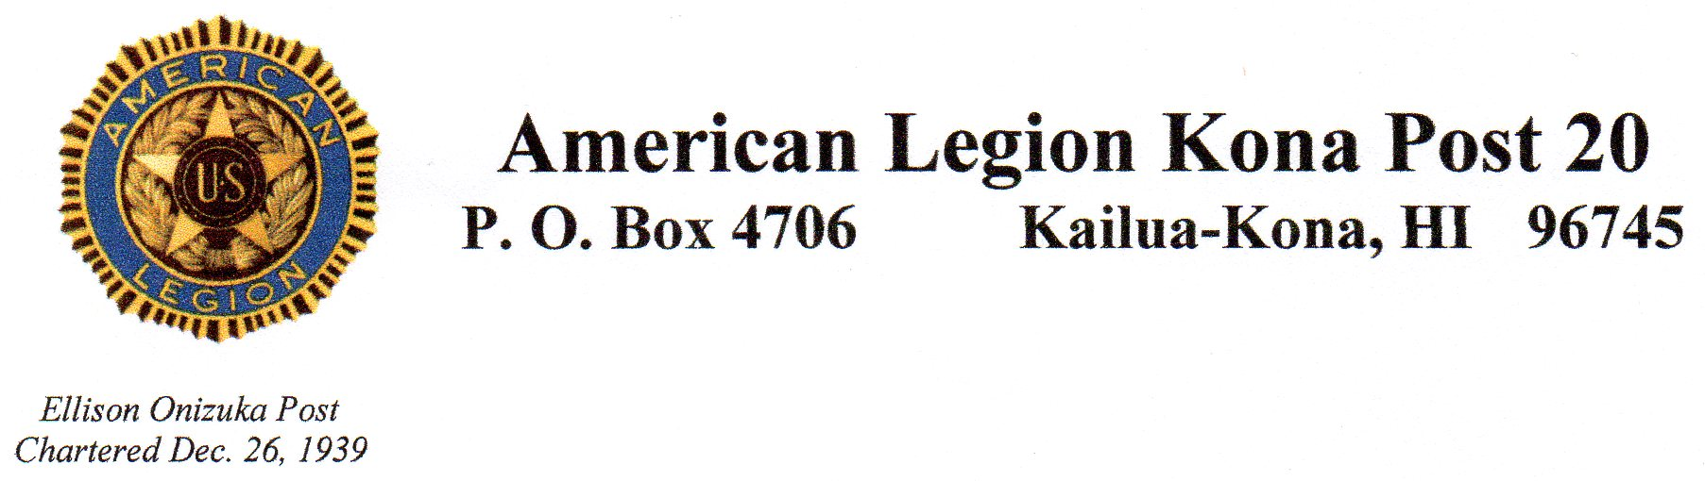**Monthly Meeting Minutes**

**January 13, 2021**

Meeting was opened by Cdr. Rico Pacatang at 4:09 pm with 14 present (2 auxiliary, 1 guest).

Salute to the flag, opening prayer, opening POW/MIA ceremony, Pledge of Allegiance, American Legion Preamble, and singing of “America the Beautiful” conducted.

Roll call by Adjutant: all present less 1st Vice,

Guest speaker Vinny DeWitt of California/Hawaii Elks Association and National Veterans Service chairman spoke to us about the programs the Elks offer veterans/homeless veterans and how he would like to partner with veteran’s organizations such as ours to implement some of these programs.

Minutes were put online, Jim Hussey made a motion to accept, seconded by Jim Traxler, passed.

Finance report given by Nestorio Domingo showed a bank balance of $8,788.62 as of today. Motion made to accept by John Ferris, seconded by Dick Scritchfield, passed.

Committee reports

District report by Antonio Gaspar: 40 members still not have not paid dues for this year. Start thinking about officers for upcoming year’s election. March 1 Antonio will be available for income tax help at Hale Halewai.

Jim Traxler reports that the projects are moving forward at the West Hawaii Veterans Cemetery. If you have ideas for projects, they have money to spend from a large donation.

Jim Hussey reports that the Oratorical local contest will be held Jan 23rd and we may have one candidate. If we do, the legion will pay for plane ticket to/from O’ahu for them and a chaperone.

Jim Hussey also reported that the golf tournament now has 21 donations, 10 hole sponsors, and about 30 players. We need more of all, would like to have a minimum of 40 players.

Rico Pacatange reported that we received the check from DAV for last year of $559.00.

Old Business

None

New Business

None

Birthdays:

Wayne Hollum 1-2, Vincent Hamiltom 1-6, Antonio Gaspar 1-9, Michael D’Amico 1-16, Phillip Heavenson 1-23, Steve Miller 1-24.

Sick

Steve Tartaglia had his surgery (bladder cancer) and is recovering. Rance remains at home recuperating. Marvin Siegfried (O’ahu) went to everlasting.

Closing prayer, closing POW/MIA ceremony and salute to the flag conducted.

Meeting adjourned at 5:10pm. Next meeting will be February 10th.

Susan Bickell, Adjutant