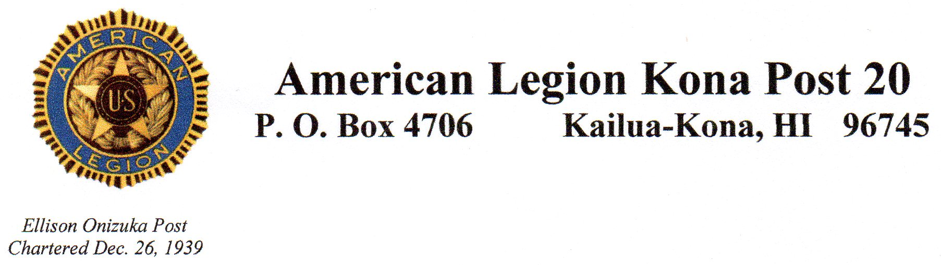

**American Legion monthly meeting**

**Sept 8, 2021**

Meeting opened at 4:00 by Susan Bickell, Commander.

Salute, Prayer, POW/MIA Opening ceremony, Pledge of Allegiance, AL Preamble, America the Beautiful.

Roll call by adjutant – Present: Susan Bickell Commander, Nestorio Domingo treasurer, Rico Pacatang 1st vice, Antonio Gaspar Judge Advocate, David Carlson Alt NEC, Rex Corpus sgt at arms, John Ferris adjutant, Jim Traxler 2nd vice. Absent Alex Okimoto chaplain, Jim Hussey Historian.

Guest- Tracy Wyatt

Minutes were put online, motion to approve made by John Ferris, seconded by Jim Traxler. Approved.

Treasurer report by Nestorio Domingo- balance $10,314.18. Motion and second made to approve . Passed.

COMMITTEE REPORTS

District: Antonio Gaspar, Adopt-A-Hwy cleanup September 18th; Antonio would like the post to buy some needed tools.

Homeless: Rex Corpus- # homeless refer to Hope services

Dave Carlson- National convention report.

Honor Guard: Rico Pacatang. New flag stands and flag cases are needed. Motion made and seconded to use $300.00 from account to buy these items and the supplies needed by Adopt A Highway. Passed. Two funerals were attended and honors rendered.

Birthdays- Anthony Carrasco, and Robert Welter 9-4, Glenn Nohiri 9-6, Robert Strickland 9-7, Jim Hussey 9-10, Maurice Lockhard 9-11, Kevin Patterson 9-15, Charles Furtado 9-17, Dave Carlson 9-18, Cliff Poffenbarger 9-21, Jon Boucher, Richard Ruchty and Ken Smith 9-22, Don Zero and Patrick Castro 9-24, George Hershberger and Henry Silva 9-26, Joe McManus 9-27, Teresa Keys 9-28.

New business- none

Old business- none

Closing prayer, POW/MIA Closing ceremony, Salute

ADJOURN 4:45PM, next meeting Oct. 13th at 4PM at Denny’s in Kona.

Submitted by John Ferris, Adjutant