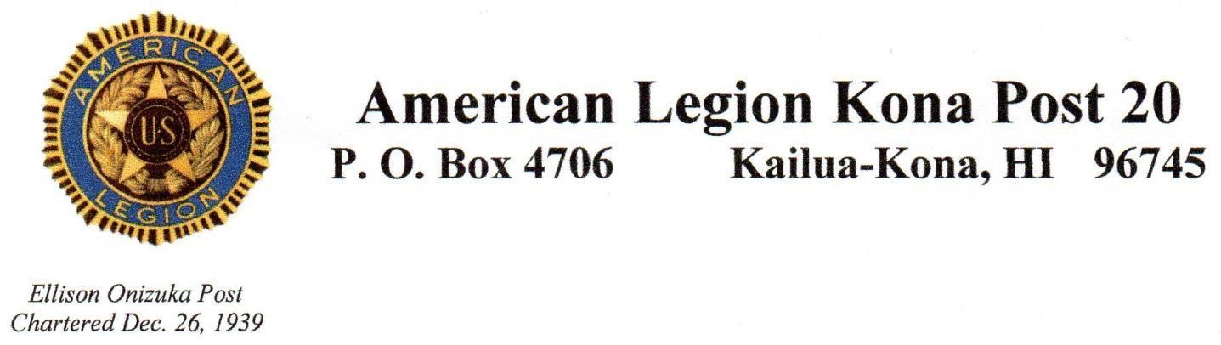

**American Legion monthly meeting**

**February 12, 2025**

Meeting opened at 4:00 PM by Susan Bickell, Commander.

Salute, Invocation, POW/MIA Opening ceremony, Pledge of Allegiance, AL Preamble, America the Beautiful.

Roll call by Adjutant, Antonio Gaspar:

Present: Susan Bickell, Commander

James Hokoana, 1st Vice

John Ferris, 2nd Vice

Antonio Gaspar, Adj/Judge Advocate

Nestorio Domingo, Treasurer

Jim Hussey, Historian

Dave Carlson, Alt NEC

Rex Corpuz, Sgt at Arms

Guests: None

Motion to approve January Minutes by John Ferris, seconded by Dick Scritchfield. Motion approved.

Motion to approve the Finance Officer’s (Jan-Feb) Report by Jim Hussey (upon audit), seconded by John Ferris. Balance for February 11, 2025 is $12,344.22.

Motion approved.

COMMITTEE REPORTS:

District IV Hawaii Report: Antonio Gaspar reported on the many activities and meetings he attended since the last meeting. His detailed report is available upon request. Reminder, adopt-a-Hwy trash pick up is on 15 March, 0600-0800.

Motion by Jim Hussey to pay$16.00 for two SAL new members, second by John Ferris, Motion approved.

HOMELESS PROGRAM: No report

BUILDING/OPERATIONS: No report

SPECIAL EVENTS/ACTIVITIES: Jim H. reports the American Legion Golf Tournament on Saturday, January 25th was a huge success. Mahalo to all who supported this event.

Hospice of Kona-Circle of Remembrance on Friday, February 7th, 2025 at the King Kamehameha Hotel grounds was a success. Past Post Commanders name Steve Whetzel was call and honored. Thank you to all who attended.

Next event will be Memorial Day services at WHVC

HONOR GUARD: Reminder, we’re still looking for (4) volunteers to post Colors at a ceremony at the Waikōloa Hotel on March 20, 2025.

OLD BUSINESS:

Antonio reports membership is at 100% paid, mahalo to all for making this happen.

NEW BUSINESS:

Boy Scout gift card sale, please see Susan to help support their organization

BIRTHDAYS: 2/6 Rosemarie Eller, 2/10 Timothy Brady, 2/12 Daniel Malakie, 2/16 Peter Lindsey, 2/25 Peter Callahan, 2/28 Russell Faust.

ILLNESS/DEATH: Jon Reynolds, eulogy at St.Micheal’s 2/22, 9-10am, followed by mass.

Reception following.

Benediction, POW/MIA Closing ceremony, Salute

ADJOURN: 4:32 PM. Next meeting 4pm, March 12, 2025, at Ekahi Loft. Dress is blue shirt.

Submitted by James Hokoana, 1st Vice.