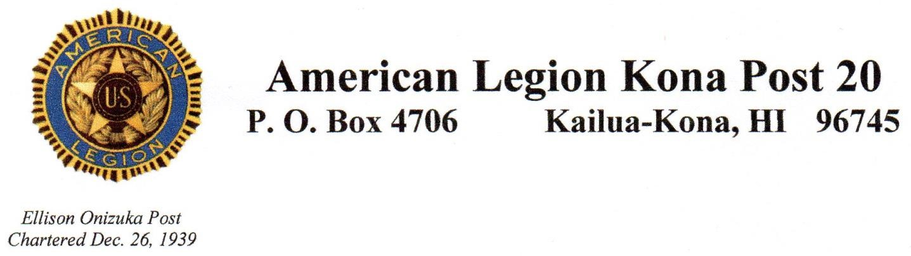

American Legion monthly meeting
June 11, 2025

Meeting opened at 4:00 PM by James Hokoana, 1st Vice Commander.
Salute, Invocation, POW/MIA Opening ceremony, Pledge of Allegiance, AL Preamble, America the Beautiful.
Roll call by Adjutant, Antonio Gaspar:
Present: James Hokoana, 1st Vice, Antonio Gaspar, Adj/Judge Advocate, Nestorio Domingo, Treasurer, Jim Hussey, Historian, Dave Carlson, NEC, Rex Corpuz, Sgt at Arms
Absent: Commander Susan Bickell (excused), Chaplain, Alex Okimoto (excused), John Ferris, 2nd Vice (excused)
Guests: None
Speaker: None
Motion to approve May Minutes by Paul Kelly, seconded by Rex Corpuz.
Motion accepted.
TREASURER REPORT: Nestorio Domingo reports: Balance as of June 11, 2025 is $7420.84. Motion to approve the Finance Officer’s Report by Jim Hussey (upon audit), seconded by Paul Kelly. Motion approved.
COMMITTEE REPORTS:
DISTRICT IV HAWAII: Antonio Gaspar reported on the many activities and meetings he attended since the last meeting. His detailed report is available upon request.
HOMELESS PROGRAM: No report- Rex Corpuz
BUILDING/OPERATIONS: No report- Jim Traxler
HONOR GUARD: No Report- Rico
SPECIAL EVENTS/ACTIVITIES:
Flag Day- Saturday, 14 June- Flag retirement ceremony-location Kealakekua Armory. Set-up and practice at 0900 followed by Ceremony at 1000. Note: Collection of brass grommets from retired flags that will be melted down for the new USS Arizona Bell and delivered to Department 1st Vice at convention.
State Convention- 19-20 June attendee’s lunch selections need to be submitted to CDR Drumheller NLT June 16th. Jim Hussey moved that Post 20 pay for attendee lunches for both days. Nestorio seconded the motion, and it was approved.
4th 0f July Parade. Meet at Kona Pool NLT 3:00 PM to decorate trailer. The parade will start at 5:00 PM.
NEW BUSINESS:
Jim Hussey moved that $452.79 be allocated for James Hokoana’s hotel cost to attend the National Membership Workshop in Indianapolis, IN. The motion was seconded by Paul Kelly. Motion approved.
Keiki golf fundraiser is planned for Sunday, June 22nd. James Hokoana moved that up to $200 to be donated to sponsor a hole. Paul Kelly seconded the motion, and it was approved. This will send a youth golfer to the US World kids (age 7-12) Championship at Pinehurst, NC.
Birthdays: 6/1 Peter Huff, 6/8 Ernest Cooley, 6/12 Arthur Demesa, 6/16 James Gannon, 6/25 Jim Traxler
Several additional Business items were discussed for informational purposes:
June 1st marks the beginning of hurricane season-everyone is encouraged to visit:
http://hawaiicounty.gov/civil-defense for a preparedness guide.

June is PTSD Awareness month-for more information visit:
PTSD.va.gov
Nami.org
Also, 9:00am every Wednesday at Umeke’s, coffee with a veteran

ILLNESS/DEATH: None reported
Benediction, POW/MIA Closing ceremony, Salute
ADJOURN: 4:55 PM. Next meeting 1600, July 9, 2025, at Ekahi Loft. The dress is white shirt.
Submitted by Jim Traxler

